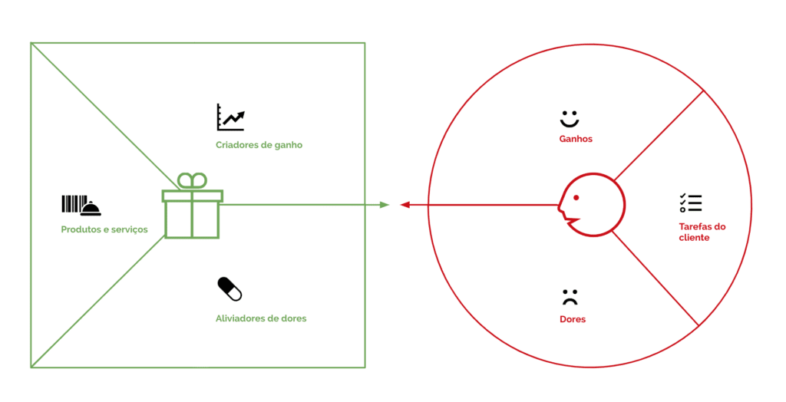 ***XPlainOn*** - Value Proposition Canvas